MADAN BHANDARI UNIVERSITY
of Science and Technology
Chitlang, Makwanpur, Nepal



Project Proposal Report
on
“Real-Time Campus Stakeholder Identification and Unknown Person Registration Using YOLOv8 and Face Recognition”

Submitted By:
Dilli Ram Chaudhary (MAS AI)
Piyush Lal Shrestha (MAS DS)
Yalamber Ingnam (MAS DS)

Submitted To:
MADAN BHANDARI UNIVERSITY
Department of Digital Technology
Chitlang, Makwanpur, Nepal
June 10, 2026

1. Introduction
Traditional CCTV systems rely on manual monitoring, making it difficult to efficiently identify campus stakeholders and track unknown individuals. Recent advances in computer vision and deep learning now enable intelligent surveillance systems to automate these tasks (Abid et al., 2024).
This research proposes a Real-Time Campus Stakeholder Identification and Unknown Person Registration Using YOLOv8 and Face Recognition. The system processes live CCTV feeds using YOLOv8 for person detection (Jocher et al., 2023) and a face recognition module to match detected individuals against a database of registered stakeholders — students, faculty, staff, and authorized personnel (Anusudha et al., 2023).
Recognized individuals are logged with their identity, timestamp, and camera location. Unrecognized individuals are flagged as unknown, with their facial image and metadata automatically stored for future verification (Liu et al., 2025). This reduces reliance on manual surveillance while providing a structured, intelligent framework for campus security and visitor record management (Abid et al., 2024).

2. Objectives
This project aims to develop an AI-powered campus surveillance and stakeholder identification system that automatically detects individuals from CCTV video streams (Mahmood et al., 2023), identifies registered campus stakeholders using face recognition (Deng et al., 2019), and records unknown persons for future verification. The system is designed to enhance campus monitoring, improve security management, and automate visitor record keeping through real-time identification and intelligent data logging (Abid et al., 2024).
The project objectives are to:
• Develop a YOLOv8-based human detection model for real-time person detection from CCTV camera feeds (Jocher et al., 2023).
• Implement a face recognition module to identify registered campus stakeholders, including students, faculty members, and administrative staff (Anusudha et al., 2023).
• Develop a centralized database for storing stakeholder information, visit records, facial images, timestamps, and camera locations.
• Design an automated logging mechanism to record stakeholder visits and maintain records of unknown persons detected within the campus premises (Liu et al., 2025).
• Build a real-time monitoring dashboard for viewing live detections, visit histories, and surveillance reports.
• Evaluate the system's performance using standard metrics such as detection accuracy, face recognition accuracy, precision, recall, and processing speed (Abid et al., 2024).

3. Problem Statement
Universities rely on CCTV systems for campus safety, but conventional setups depend entirely on manual monitoring, a process that is labor-intensive, error-prone, and inefficient, especially across multiple camera feeds during peak hours (Mahmood et al., 2023).
Currently, there is no automated mechanism to distinguish registered campus stakeholders from unknown visitors. Security personnel must manually review footage to verify identities or trace individuals, which becomes increasingly unmanageable in crowded environments (Abid et al., 2024).
The key problems are:
- Manual monitoring of camera feeds is inefficient and prone to oversight (Mahmood et al., 2023).
- No automated identification: recognizing stakeholders or flagging unknown individuals requires manual effort (Anusudha et al., 2023).
- Poor record management: logging visit timestamps, camera locations, and appearance history is inconsistent and time-consuming (Liu et al., 2025).
- Inefficient footage search: locating a specific individual across historical recordings is slow and tedious (Abid et al., 2024).
- Lack of intelligence: existing systems capture video but offer no automated detection, recognition, or logging capabilities (Jocher et al., 2023).

4. Proposed Solution
The system captures live CCTV feeds and uses YOLOv8 for real-time person detection and InsightFace for facial embedding generation and identity matching against a registered stakeholder database.
Recognized individuals are automatically logged with their identity, timestamp, and camera location. Unrecognized individuals are flagged as unknown, with their facial image and metadata stored for future verification.
The system will:
- Detect persons in live video frames using YOLOv8
- Extract and match facial embeddings via InsightFace against the stakeholder database
- Log visit records for recognized stakeholders and capture facial images of unknown persons
- Provide a Streamlit-based dashboard for real-time monitoring, search, and reporting

5. Methodology
- Data Collection
- Collect stakeholder images from institutional or campus environments.
- Prepare labeled data for Students, Faculty, Staff and Visitors/Unknown.
- Model Development
• Train and fine-tune YOLOv8 via transfer learning for person detection under campus-specific surveillance conditions(Jocher et al., 2023).
• Use InsightFace to extract facial embeddings and match detected individuals against the registered stakeholder database (Deng et al., 2019).
• Develop a recognition pipeline that classifies individuals as registered stakeholders or unknown persons based on facial similarity scores (Anusudha et al., 2023).
- Optimize both models for real-time performance and deployment(Jocher et al., 2023).
- System Integration
• Integrate CCTV feeds with the detection and recognition pipeline for real-time monitoring (Mahmood et al., 2023).
• Store stakeholder identities, embeddings, visit records, and unknown person data in a centralized database.
• Automatically capture and log facial images, timestamps, and camera locations of unknown individuals (Liu et al., 2025).
• Build a Streamlit dashboard for live monitoring, visit tracking, record management, and reporting.
- Evaluation
• Test the system under real campus surveillance conditions across various locations and times (Abid et al., 2024).
• Evaluate YOLOv8 using Precision, Recall, F1-Score, and mAP (Jocher et al., 2023).
• Assess face recognition using identification accuracy, recognition rate, and false acceptance/rejection rates (Deng et al., 2019).
• Measure real-time performance in terms of FPS and response time (Abid et al., 2024).
• Analyze the accuracy and effectiveness of the automated logging mechanism.

6. Expected Outcomes
Upon successful completion of the project, the following outcomes are anticipated:
- A functional prototype for real-time person detection using YOLOv8 and automated stakeholder identification via face recognition.
- Automatic logging of stakeholder visits and unknown person records, including facial images, timestamps, and camera locations.
- A centralized database maintaining stakeholder profiles, visit histories, and unknown person records.
- A Streamlit dashboard for live monitoring, record management, search, and reporting.
- Reduced reliance on manual surveillance with improved campus monitoring efficiency.

7. Economic and Societal Impact
- Economic Impact
- Cuts manpower costs by eliminating continuous manual surveillance and footage review.
- Automates identification and record management, reducing administrative overhead.
- Maximizes existing CCTV infrastructure value through intelligent video analytics.
- Improves operational efficiency with faster access to surveillance data.
- Societal Impact
- Enhances campus security through real-time identification and automated monitoring.
- Enables accurate digital record-keeping of visits and unknown person appearances.
- Reduces security personnel workload and promotes smarter campus environments.
- Advances digital transformation in educational institutions through AI-driven surveillance.

8. Tools and Technologies
Hardware
- Camera / Webcam/ CCTV camera: IP camera or standard webcam for live video input.
- Computing Device: Laptop, workstation, or server for model inference and database handling.
Software
- YOLOv8: Real-time person detection and stakeholder classification.
- InsightFace: Face embedding extraction and identity matching.
- Python: Primary programming language for system development.
- OpenCV: Video capture, frame preprocessing, and output rendering.
- PyTorch: Deep learning backend for model training and deployment.
- SQL (SQLite / MySQL): Storage of stakeholder identity and access logs.
- Streamlit: Dashboard for real-time monitoring and reporting.
- NumPy / Pandas: Data processing and log management.
- LabelImg / Roboflow: Dataset annotation in YOLO format.
- Matplotlib / Seaborn: Basic analytics and visualization.

9. Project Timeline
The project spans 15 weeks across six structured phases, as illustrated in the Gantt chart below.
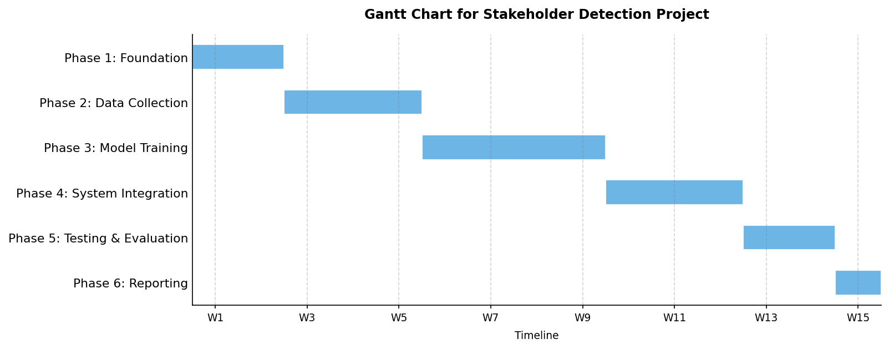

10. References
- Abid, M. M., Mahmood, T., Ashraf, R., Faisal, C. M. N., Ahmad, H., & Niaz, A. A. (2024). Computationally intelligent real-time security surveillance system in the education sector using deep learning. PLOS ONE.
https://pmc.ncbi.nlm.nih.gov/articles/PMC11238971/
- Anusudha, K., et al. (2023). Real-time face recognition system based on YOLO and InsightFace. ResearchGate.
https://www.researchgate.net/publication/374027853

- Deng, J., Guo, J., Xue, N., & Zafeiriou, S. (2019). ArcFace: Additive angular margin loss for deep face recognition. Proceedings of the IEEE/CVF Conference on Computer Vision and Pattern Recognition (CVPR), 4690–4699. https://www.researchgate.net/publication/338506499_ArcFace_Additive_Angular_Margin_Loss_for_Deep_Face_Recognition

- Jocher, G., Chaurasia, A., & Qiu, J. (2023). Ultralytics YOLOv8. Ultralytics. https://github.com/ultralytics/ultralytics

- Liu, Z., et al. (2025). A review of face recognition technology: From algorithms to real-time systems with InsightFace. ResearchGate. https://www.researchgate.net/publication/397048039

- Mahmood, T., Ashraf, R., & Faisal, C. M. N. (2023). A deep learning based human detection and tracking for security surveillance systems. ResearchGate. https://www.researchgate.net/publication/370032906

